

ANSWERS

**Year 11 ATAR Human Biology**

**AEHBY**

**Task 2: Mid Semester 1 Test**

**Multiple Choice Questions Booklet**

**Multiple Choice Section 15 Marks**

1. The active site of the enzyme molecule:
   1. is the location where the enzyme combines with the substrate.
   2. will attach to any substrate placed with the enzyme
   3. requires activation energy to bind to the substrate
   4. can never be altered in shape
2. The cell theory could best be described as

1. all living organisms are made up of cells and materials produced by cells.
2. all living organisms are made up of cells and progressively become more complex.
3. the structure of all living organisms and the way they function result from the activity of all its cells.
4. all living organisms cells are small so they can exchange materials effectively
5. Phagocytosis is best represented as which of the following transfer mechanisms?
6. Active transport
7. Exocytosis
8. Pinocytosis
9. Endocytosis
10. Red blood cells are produced in the
11. yellow bone marrow.
12. spleen.
13. liver.
14. red bone marrow.
15. Blood returning to the heart from the brain will enter the:

a) left atrium

b) left ventricle

c) right ventricle

d) right atrium

1. Listed below are some of the events that occur during the cardiac cycle:
2. Ventricles fill.
3. Ventricles contract, atrioventricular valves close.
4. Atria contract.
5. Semilunar valves close.

What is the correct order of events during the cardiac cycle?

1. iii, i, ii, iv.
2. i, iii, ii, iv.
3. iv, iii, ii, i.
4. iii, i, iv, ii.
5. Consider the following diagram, then identify which of the following statements about the diagram is CORRECT.
6. 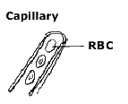

A

B

a) oxygen would move from A to B by active transport and carbon dioxide would move from B to A by diffusion

b) carbon dioxide would move from B to A by active transport and oxygen would move from B to A by diffusion

c) both oxygen and carbon dioxide would move between A and B by diffusion

d) both oxygen and carbon dioxide would move between A and B by osmosis

1. Which of the following is nota feature of the respiratory system that aids in gas exchange?
2. Moist surface.
3. Rich capillary network.
4. Thin alveolar membrane.
5. Each alveolus has a small surface area.
6. In a cell the reactions of aerobic respiration occur in the
   1. mitochondria and release carbon dioxide, water and ATP.
   2. cytoplasm and release ADP.
   3. cytoplasm and release 36 molecules of ATP
   4. mitochondria and require 36 molecules of ATP

10. Proteins are made up of units called:

a) Peptide bonds

1. Amino acids
2. Glucose
3. Monosaccharides

11. During the process of expiration the:

1. diaphragm lowers
2. ribs move upwards and outwards
3. size of the thoracic cavity increases
4. pressure inside the thoracic cavity increases

12. Which of the following consist of a network of intracellular membranes with attached ribosomes?

a) rough endoplasmic reticulum

b) smooth endoplasmic reticulum

c) mitochondria

d) Golgi apparatus

13. Mammalian sperm cells expend a large amount of energy in moving through the female reproductive tract. On the basis of this information you would predict that these cells would contain a large number of:

* 1. vacuoles
  2. mitochondria
  3. ribosomes
  4. chloroplasts

14. What is the correct order of cell organisation?

a) Cells 🡪 tissues 🡪 systems 🡪 organs 🡪 organsism

b) Tissues 🡪 cells 🡪 organs 🡪 systems 🡪 organism

c) Cells 🡪 tissues 🡪 organs 🡪 systems 🡪 organism

d) Cells 🡪 tissues 🡪 organs 🡪 organism 🡪 systems

15. Which of the following lists has an anabolic process followed by a catabolic process?

|  |  |  |
| --- | --- | --- |
|  | **Anabolic process** | **Catabolic process** |
| a) | Respiration | Protein synthesis |
| b) | Protein synthesis | Fat digestion |
| c) | Anaerobic respiration | DNA replication |
| d) | Anaerobic respiration | Aerobic respiration |



**Year 11 ATAR Human Biology**

**Task 2: Mid Semester 1 Test**

**Answer Booklet**

Time Allocated: 50 minutes

Weighting 12.5%

**Name: ___________________________________________**

|  |  |  |  |
| --- | --- | --- | --- |
| **Multiple Choice** | **Short Answer** | **Extended Answer** | **Total** |
| /15 | /30 | /12 | /57 |

**SECTION ONE:**

Multiple choice answers. Cross (X) through the correct answer.

|  |  |  |  |  |
| --- | --- | --- | --- | --- |
| **1** | xxxx | b | c | d |
| **2** | xxxx | b | c | d |
| **3** | a | b | c | xxxx |
| **4** | a | b | c | xxxx |
| **5** | a | b | c | xxxx |
| **6** | xxxx | b | c | d |
| **7** | a | b | xxxx | d |
| **8** | a | b | c | xxxx |
| **9** | xxxx | b | c | d |
| **10** | a | xxxx | c | d |
| **11** | a | b | c | xxxx |
| **12** | xxxx | b | c | d |
| **13** | a | xxxx | c | d |
| **14** | a | b | xxxx | d |
| **15** | a | xxxx | c | d |

**Short Answer Section 30 Marks**

16. Enzymes are chemicals in the body that are vital for cells to carry out life processes.

* 1. Name the type of molecule enzymes are made of. (1 mark)

Proteins (1)

* 1. Explain why enzymes are so vital for cells to function (2 marks)

Lower activation energy/speed up chemical reaction (1)

Allow these chemical reactions to occur at body temp (1)

* 1. Explain, using the lock and key model, how enzymes are thought to work. Use a diagram in your answer. (5 marks)

Any of the following 5 points:

Substrate(s) fit(s) into active site of the enzyme (1)

Forms the enzyme-substrate complex (1)

Bonds are broken/formed (1)

To form enzyme product complex (1)

Product separates from the enzyme/active site (1)

Makes enzyme molecule available to attach to another substrate molecule (1)

* 1. All chemical reactions in the human body can be described as being anabolic or catabolic. Which type of reaction is respiration? Explain your answer. (2 marks)

Catabolic (1)

Glucose broken down into smaller molecules (0.5) and release energy (0.5)

17. The diagram below shows a cross section through the middle of the heart

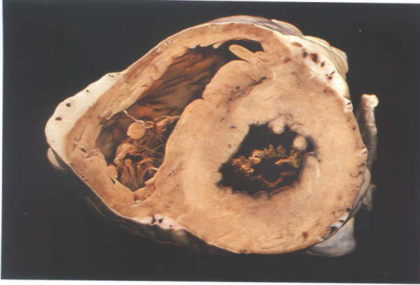

Figure 1.

What is the main structural difference between the right and left ventricle and explain why this is significant to their respective functions? (3 marks)

The left wall / muscle is much thicker (1) as the left side pumps blood to systemic circulation (1) whereas the right side only pumps blood to the lungs / pulmonary circulation (1)

18. Each cell is surrounded by a cell membrane that separates the cell contents from the external environment. Refer to the diagram below to answer the following question.

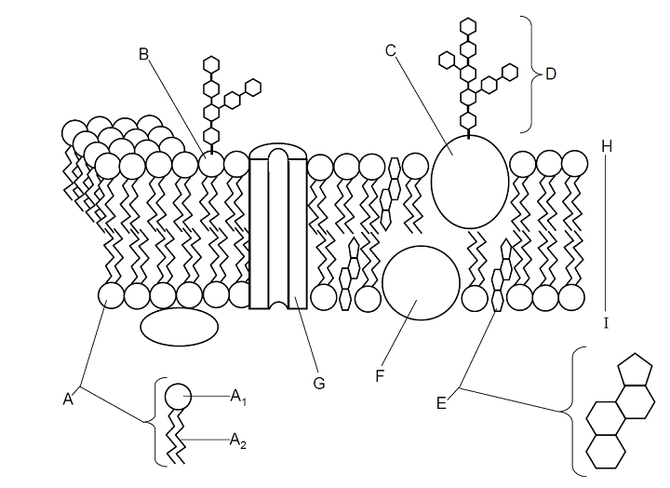

* 1. Name the molecules represented by the following structures. (3 marks)

A1 Hydrophyllic (0.5) head (0.5)

A2 Hydrophobic (0.5) tail (0.5)

G Protein channel (1)

* 1. Phagocytosis requires energy to transport substances across the cell membrane.

Use the space below to draw and label a diagram of Phagocytosis: (4 marks)

Correct process drawn (1 mark)

Direction of process correct (1 mark)

Plasma membrane labelled (1 mark)

Vacuole labelled (1 mark)

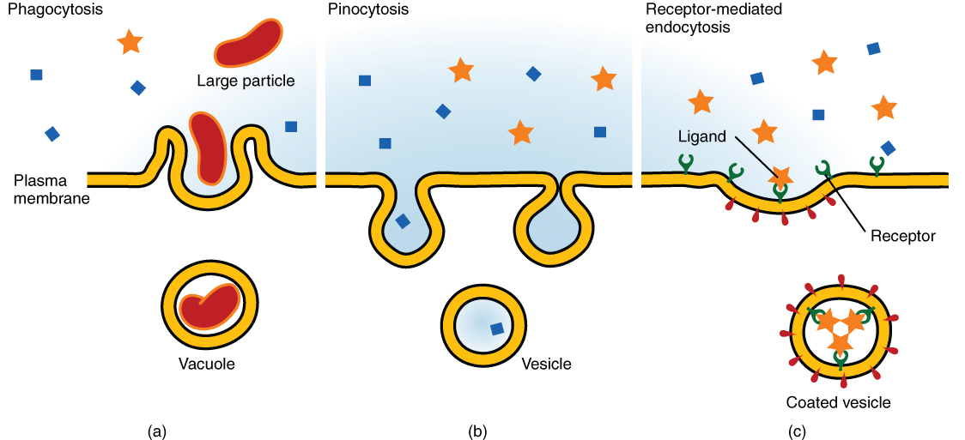

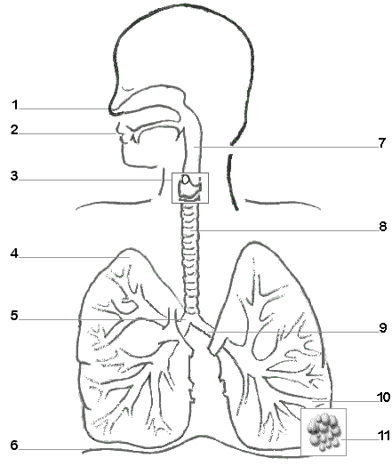

19.

Figure 2.

* 1. Identify the following parts of the respiratory system. (4 marks)

|  |  |
| --- | --- |
| 1. Nasal cavity | 3. Larynx |
| 5. Bronchiole | 6. Diaphragm |

* 1. Structure 8 is a tube that allows air to enter and leave the lungs at different pressures. Describe the structures that allow this to occur, without the tube collapsing. (1 mark)

Trachea has C shaped cartilage rings that keep the tube open (needs to name structure for 1 mark)

* 1. The following questions relate to the picture below of a U-tube with a selectively permeable membrane:

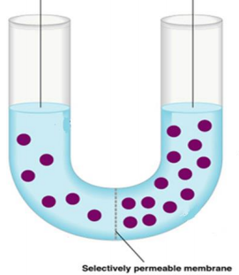

B

A

1. Which side (A or B) has more solute? (1 marks)

B

1. Which side (A or B) has more solvent ? (1 marks)

A

1. Next to the picture, draw what the final U-tube will look like. (3 marks)

Picture must include: side B higher water level (1) side A lower water level (1) Amount of solute unchanged 6 side A and 13 side B (1)

**Extended Response Section 12 Marks**

* 1. Respiration is a process that releases energy. This energy must be temporarily stored.

1. Explain why it is important that energy is stored in this way. (3 marks)

* ADP is a storage molecule of ATP that all organelles in the cell can utilise to obtain energy (1)
* ATP easily diffuses (smaller molecule), easier storage at site of release (↑ efficiency) (1)
* Recyclable (1)

1. Describe the 3 different processes listed below that allow substances to move across the cell membrane. (6 marks)

(i) Facilitated diffusion (ii) Diffusion (iii) Exocytosis

* + 1. Facilitated diffusion
* The movement of a substance from a region of high concentration to a region of low concentration/ passive (1)
* Through a carrier/ transport protein/protein channel (1)
  + 1. Diffusion
* The movement of a substance from a region of high concentration to a region of low concentration (1)
* So that particles are evenly distributed/ passive/ affected by size/ gradient determines rate/without energy (1)
  + 1. Exocytosis
* Contents of a vesicle are expelled out through the cell membrane (1)
* Low to high concentration ATP needed (1)

1. Identify three (3) factors affecting the exchange of materials between cells and their environment with an example for each factor. (3 marks)

* Surface area (0.5) example microvilli (0.5)
* Concentration gradient (0.5) example of any concentration gradient occurring in the body such as O2 gas exchange (0.5)
* Particle size (0.5) example of protein too large or glucose too small (0.5)

**END OF ASSESSMENT**